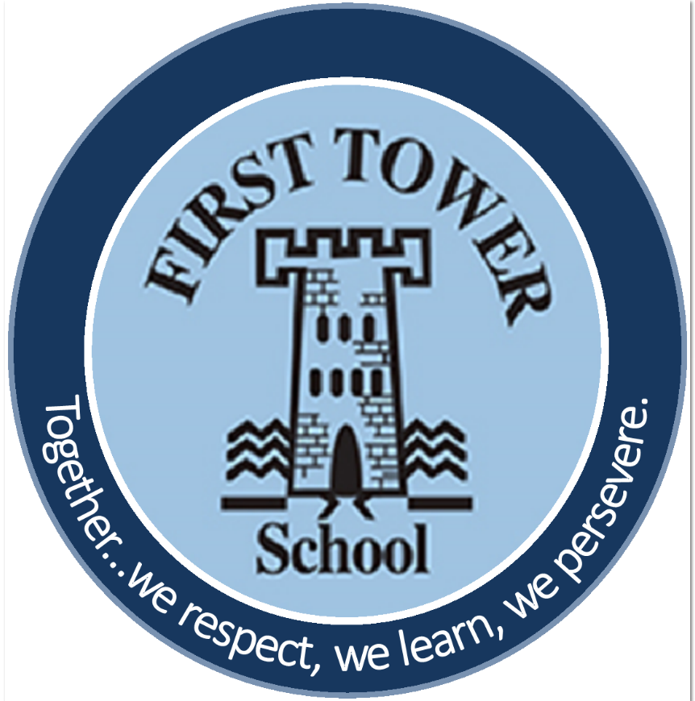

First Tower School
Physical Education (PE) Policy
September 2023

Introduction and Vision Statement
At First Tower School, we aim to instil a passion for PE to ensure that every child has the opportunity to be the best they can be in their PE lessons, sport and active playtimes. We strive to give children the opportunity to be challenged internally and with other schools to instil values of perseverance, respect, friendship and good sportsmanship. We aim to promote a positive attitude towards a healthy and active lifestyle. This includes providing children with opportunities to be active throughout the day and across the curriculum.

Our Aims
- To include all pupils in physical activity and give them the opportunity to reach their full potential regardless of ability, age, gender, cultural or ethnic background.
- To increase pupils’ participation in and enjoyment of physical activity within and outside the curriculum.
- To develop the concept of fair play by having positive attitudes towards understanding and applying the conventions and rules of competition.
- To improve pupils’ health and develop an understanding of the importance of activity in maintaining a healthy lifestyle by taking ownership of their own fitness levels.
- To allow pupils to work in environments which are safe, familiar, different and challenging and to be concerned with their own and others’ safety in all activities.
- To develop the ability to work both independently and co-operatively; to communicate with and respond positively towards others whether as participants, team members, organisers or spectators.
- To provide opportunities for cross-curricular learning within PE lessons.

Teaching and Learning
At First Tower, we strive to offer two hours of high-quality PE a week. Each year group is given dedicated use of either the Sports Hall/School Hall or outdoor playgrounds throughout the year. Throughout the year, PE lessons with either be taught by the class teacher or a specialist coach in a particular area. These coaches are offered to school through Jersey Sport and Sports Development officers. Swimming is currently taught in Years 4 and 5. This is taught on an off-site facility by specialist trained swimming teachers. There are opportunities for all children to join in a variety of extra-curricular sports clubs run by staff and outside agencies. This gives them the opportunity to develop their skills, enjoy performance and encourage sport as part of a healthy lifestyle.
During PE lessons, children should remain physically active for at least 10 consecutive minutes by the end of Key Stage 1 and 20 consecutive minutes by the end of Key Stage 2. Opportunity and provision in PE and extra-curricular activities will be planned and delivered to meet the needs of all pupils. Differentiation should enable all pupils to achieve to the best of their ability. Differentiation can be catered for in a range of ways, such as: grouping children by ability and setting different tasks for each group; providing a range of challenges through the provision of a variety of appropriate resources/equipment; individual, paired and group work; and by providing extension activities or more skills based activities for higher ability children.

PE Curriculum
At First Tower, we follow the Jersey Curriculum for Physical Education.
Aims
The Jersey curriculum for physical education aims to ensure that all pupils:
- develop competence to excel in a broad range of physical activities
- are physically active for sustained periods of time
- engage in competitive sports and activities
- use and experience the natural outdoor learning resources of Jersey
- lead healthy, active lives.
Subject Content
Health and Fitness:
All schools must provide an element to their Physical Education curriculum that addresses Health and Fitness.
In particular pupils should be taught to:
- know the importance of leading an active lifestyle
- use the unique outdoor opportunities of Jersey to develop health related fitness and wellbeing
- know the importance of nutrition and re-hydration as an integral part of health, wellbeing and fitness.

Swimming and Water Safety
All schools must provide swimming and safety instruction either in Key Stage 1 or Key Stage 2.
In particular, pupils should be taught to:
- swim competently, confidently and proficiently over a distance of at least 25 metres
- use a range of strokes effectively [for example, front crawl, backstroke and breaststroke]
- perform basic survival and rescue skills in pool based situations
- keep themselves safe and understand the potential dangers of Jersey’s beaches.
Key Stage 1
Pupils should develop fundamental movement skills, become increasingly competent and confident and access a broad range of opportunities to extend their agility, balance and coordination, individually and with others. They should be able to engage in competitive (both against self and against others) and co-operative physical activities, in a range of increasingly challenging situations.
Pupils should be taught to:
- master basic movements including running, jumping, throwing and catching, as well as developing balance, agility and co-ordination, and begin to apply these in a range of activities
- participate in team games, developing simple tactics for attacking and defending
- perform dances using simple movement patterns.
Key Stage 2
Pupils should continue to apply and develop a broader range of skills, learning how to use them in different ways and to link them to make actions and sequences of movement. They should enjoy communicating, collaborating and competing with each other. They should develop an understanding of how to improve in different physical activities and sports and learn how to evaluate and recognise their own success.
Pupils should be taught to:
- use running, jumping, throwing and catching in isolation and in combination.
- play competitive games, modified where appropriate [for example, badminton, basketball, cricket, football, hockey, netball, rounders and tennis], and apply basic principles suitable for attacking and defending
- develop flexibility, strength, technique, control and balance [for example, through athletics and gymnastics]
- perform dances using a range of movement patterns
- take part in outdoor and adventurous activity challenges both individually and within a team
- compare their performances with previous ones and demonstrate improvement to achieve their personal best.

Health and Safety
In order to ensure the safeguarding of our children, staff will follow simple health and safety guidelines at First Tower.
Clothing and jewellery:
Children will wear suitable clothing for indoor and outdoor PE. Children will be expected to wear the correct First Tower PE kit. This will include suitable training shoes (unless in the hall in which children can be bare-foot e.g. gymnastics), navy shorts and/or tracksuit bottoms and a white polo top.
Earrings should be removed. As in the guidelines for First Tower uniform, children are allowed to wear single studs. Every opportunity must be taken for young children to have their earrings taken out at home prior to a PE lesson. If children are unable to take out their earrings, parents must ensure that their child’s earrings are taped over before school. First Tower School will accept no responsibility over injury if a child’s earrings are not covered.
No other jewellery should be worn.
Hair should be securely tied back.
Role of the Subject Leader
The role of the PE Subject Leader at First Tower School is to ensure that once the children have left the school at the end of Year 6, they have been taught all aspects of the Physical Education curriculums. This will be monitored through student/teacher questionnaires, planning scrutiny and lesson observations.
The Subject Leader will also keep a note of visitors (i.e. external coaches), extra-curricular activities, competitions and equipment. This will be to ensure that the children are being provided with a balanced, varied and enriching curriculum.

Reviewed: September 2023
Policy to be reviewed and updated by no later than September 2024

