

First Tower School

Play Policy 2024

Date: | March 2024
To be reviewed: | September 2024

First Tower Play Policy
- Commitment
Our school undertakes to refer to this play policy in all decisions that affect children’s play. Our school is committed to providing the strategic and operational leadership needed to provide and maintain quality play provision for all of our children.
- Rationale
Our school believes that all children need opportunities to play that allow them to explore, manipulate, experience and affect their environment. We believe play provision should be welcoming and accessible to every child, irrespective of gender, sexual orientation, economic or social circumstances, ethnic or cultural background or origin, or individual abilities.
The OPAL Primary Programme rationale is that “… better, more active and creative playtimes can mean happier and healthier children, and having happier, healthier, more active children usually results in a more positive attitude to learning in school, with more effective classroom lessons, less staff time spent resolving unnecessary behavioural problems, fewer playtime accidents, happier staff and a healthier attitude to life.”
At First Tower we know that our pupils’ make the best progress when their learning and play encompasses our school values; Together…we respect, we learn, we persevere. Our commitment to provide quality play experiences supports pupils to achieve their very best.
- Definition and value of play
Play is defined as a process that is intrinsically motivated, directed by the child and freely chosen by the child. Play has its own value and provides its own purpose. It may or may not involve equipment or other people. It may be serious or light hearted. It may produce something or it may be done simply for its own sake. It allows children an opportunity to be creative, to make decisions and to assess and manage risks.
At First Tower Primary School we recognise that play may need to make a noise, get dirty, make a mess and sometimes be out of the direct gaze of adults. We believe that the role of the adults is to support the play process.
We believe play has many benefits, including:
- Play is critical to children’s health and wellbeing, and essential for their physical, emotional, social, spiritual and intellectual development.
- Play enables children to explore the physical and social environment, as well as different concepts and ideas.
- Play enhances children’s self-esteem and their understanding of others through freely chosen social interactions, within peer groups, with individuals, and within groups of different ages, abilities, interests, genders, ethnicities and cultures.
- Play requires ongoing communication and negotiation skills, enabling children to develop a balance between their right to act freely and their responsibilities to others.
- Play enables children to experience a wide range of emotions and develop their ability to cope with these, including sadness and happiness, rejection and acceptance, frustration and achievement, boredom and fascination, fear and confidence.
- Play encourages self-confidence and the ability to make choices, problem solve and to be creative.
- Play maintains children’s openness to learning, develops their capabilities and allows them to push the boundaries of what they can achieve.

- Aims
In relation to play our school aims to:
- Ensure our school play setting provides a very challenging and stimulating environment.
- Allow children to take risks and use a common-sense approach to the management of these risks and their benefits.
- Adults to use a common-sense approach to the management of safe enough, risk-taking, ensuring they preserve the benefits of the activity.
- Provide opportunities for children to develop their relationships with each other.
- Enable children to develop respect for their surroundings and each other.
- Aid children’s physical, emotional, social, spiritual and intellectual development.
- Provide a range of environments that will encourage children to explore and play imaginatively.
- Provide a range of environments that will support children’s learning across the curriculum and learning about the world around them.
- Promote independence and teamwork within children.
- Build emotional and physical resilience.
- Ensure adults respect these rights, providing inclusive opportunities for creative, exciting play, use of restorative justice to resolve conflicts and to support children who have additional needs at playtime.

- Rights
Our school recognises the UN Convention on the Rights of the Child, which includes the right to play, recreation and leisure (Article 31) and the right of children to be listened to on matters important to them (Article 12). We acknowledge that we have a duty to take these rights seriously and listen to children’s views on their play.
- Benefit and risk
‘Play is great for children’s wellbeing and development. When planning and providing play opportunities, the goal is not to eliminate risk, but to weigh up the risks and benefits. No child will learn about risk if they are wrapped in cotton wool.’
Managing Risk in Play Provision: An Implementation Guide (Play Safety Forum, 2012)
The school will use the Health and Safety Executive guidance document Children’s Play and Leisure – Promoting a Balanced Approach (September 2012) as the principal value statement informing its approach to managing risk in play. In doing so, the school will adopt a risk-benefit approach as detailed in Managing Risk in Play Provision: An Implementation Guide (Play Safety Forum, 2012).
Risk-taking is an essential feature of play provision and of all environments in which children legitimately spend time at play. Play provision aims to offer children the chance to encounter acceptable risks as part of a stimulating, challenging and managed play environment. As outlined in the play sector publication ‘Best Play’, play provision should aim to ‘manage the balance between the need to offer risk and the need to keep children and young people safe from harm’.
In addition to standard risk-benefit assessments the school will practise dynamic risk management with children, encouraging them to identify and manage risks in an environment where adults are present to support them.
- Supervision
The law requires that children in Jersey school have supervision at a ratio of 1:75. During the school day there should be one or more adults present outdoors. First Tower Primary School has generous ratios of adults to children for playtimes and lunchtimes. We recognise OPAL’s three models of supervision: Direct, Remote and Ranging. Except for new children in Reception, whose skills and orientation in the school environment need to be assessed, the school does not believe direct supervision is possible or beneficial. Supervisors will use ranging and remote supervision models, so that children can quickly find an adult and adults can move around the site to gain an awareness of the kinds of play and levels of risk likely to be emerging.
See attached plan of supervision zones.
- The adult’s role in play
The school will help children maximise the benefits they can gain from play by the provision of trained staff who are informed by and work in accordance with the Playwork Principles. Staff will use and refer to these principles when appropriate interventions are needed, and ultimately will strive for facilitating an environment that nurtures children’s self-directed play.
The playworker’s core function is to create an environment that will stimulate children’s play and maximise their opportunities for a wide range of play experiences. A skilled and experienced playworker is capable of enriching the child’s play experience both in terms of the design and resources of the physical environment and in terms of the attitudes and culture fostered within the play setting. Playworkers are a channel of access to new materials and tools and they can act as a stimulus to children to explore and learn. They are also available to participate in the play if invited.
- Equality and diversity
Through providing a rich play offer meeting every child’s needs, we will ensure all children, regardless of age, gender, race, disability or other special needs, can develop and thrive, build strong relationships and enjoy school.
- Environment and weather
We believe that a rich play setting should ensure that all children have access to stimulating environments that are free from unacceptable or unnecessary risks and thereby offer children the opportunity to explore for themselves through their freely chosen play. We will strive to continually improve the quality and diversity of our school’s grounds to enhance play. We will use the document ‘Best Play’ to guide us on what a quality play environment should contain. www.freeplaynetwork.org.uk/pubs/bestplay.pdf
The weather in the UK is often poor so the OPAL (Outdoor Play and Learning) approach states that we only keep children inside in dangerous weather e.g. storms or hail. It is the responsibility of schools as centres of child development to ensure children are equipped to live healthy lives in the UK climate. This means being dressed for all weathers and being resilient to hot and cold, wet and dry. There is also a crisis of lack of movement in childhood and inactivity can be a great danger to children’s development. During the winter, viruses such as colds and flu spread through the air in enclosed spaces. Playing in the mud and dirt is also scientifically proven to boost immune systems. The healthiest place to be is outside!
In instances of poor weather, a decision will be made by SLT or Curricular Lead for Play as there may be a need for a dynamic risk assessment and shorter outdoor playtime to take place. Members of staff on duty with a two way radio could make a request to end play early or take a short break from the outside environment should the weather decline rapidly.
- Clothing
Children should bring a sensible coat, preferably a waterproof one with a hood, and a change of clothes including socks, trousers and jumpers in case they need to get changed. They can also bring welly boots to wear in wet weather. Gloves, scarves, and hats would also be sensible on colder days.

A parent guide to outdoor play and learning:
https://outdoorplayandlearning.org.uk/wp-content/uploads/2021/07/NonOpalSchool-A5-Parents-Guideweb.pdf
Videos about outdoor play and learning:
https://outdoorplayandlearning.org.uk/research-and-evidence/videos/



First Tower School Playground Charter
We have the responsibility to make sure everyone enjoys playtime by making sure:

- We treat each other kindly and respectfully.
- We share equipment fairly and kindly.
- We take care of the equipment, and we tidy it away when we are finished.
- We keep everybody safe.
- We help people if they need us.
- We ask grownups if we need help to sort out our problems.
- We have a positive attitude, and we have fun.

Playground Supervision Zones Map
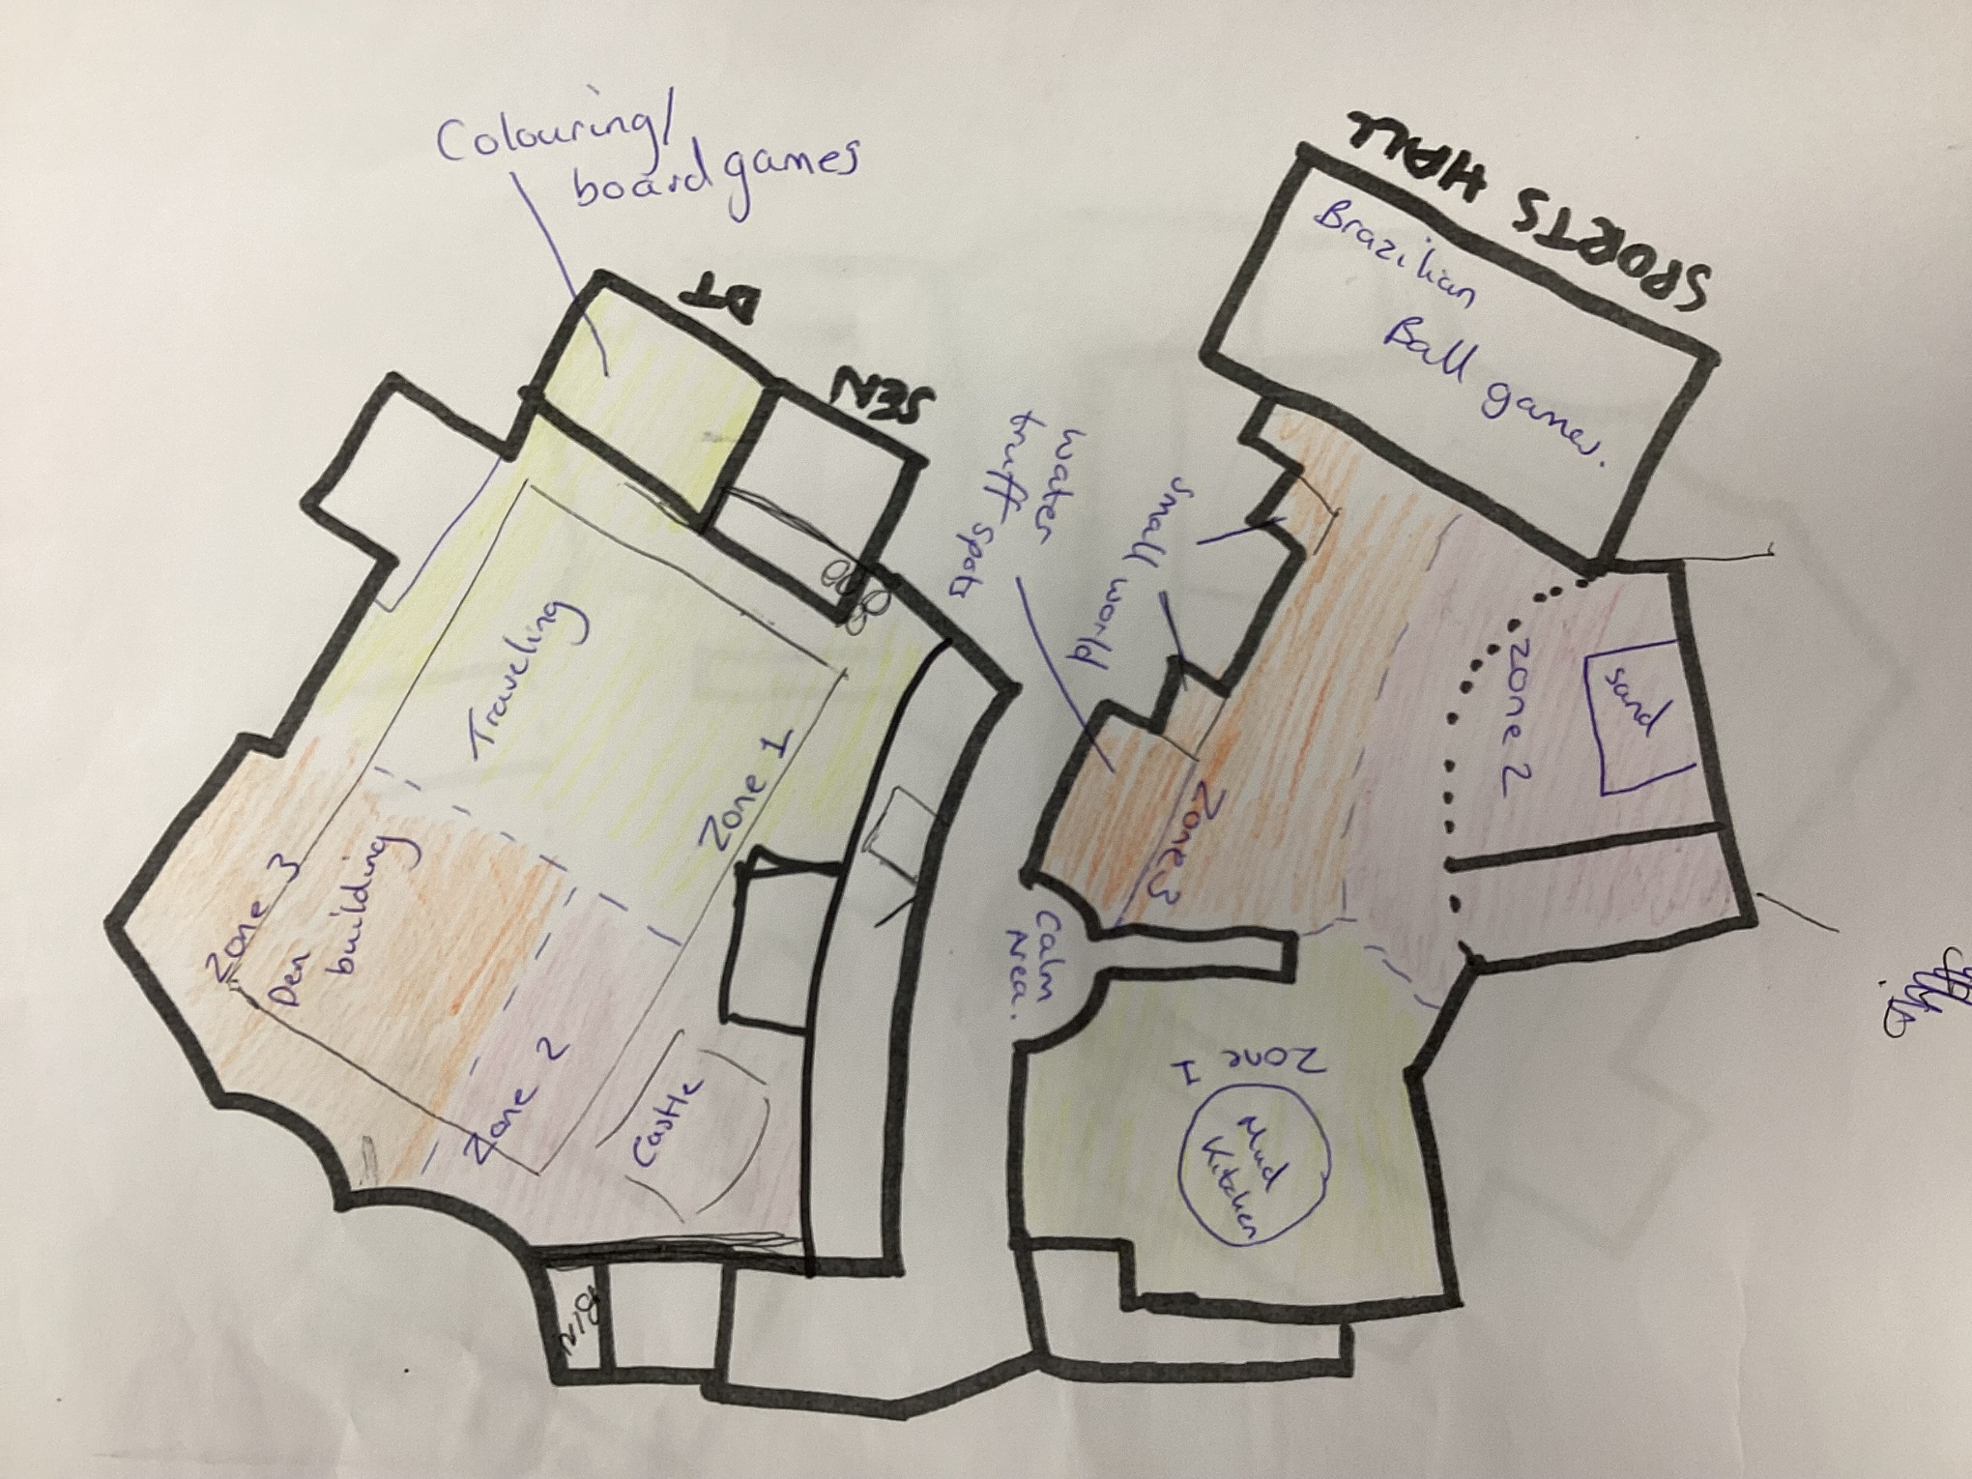

Play Types



