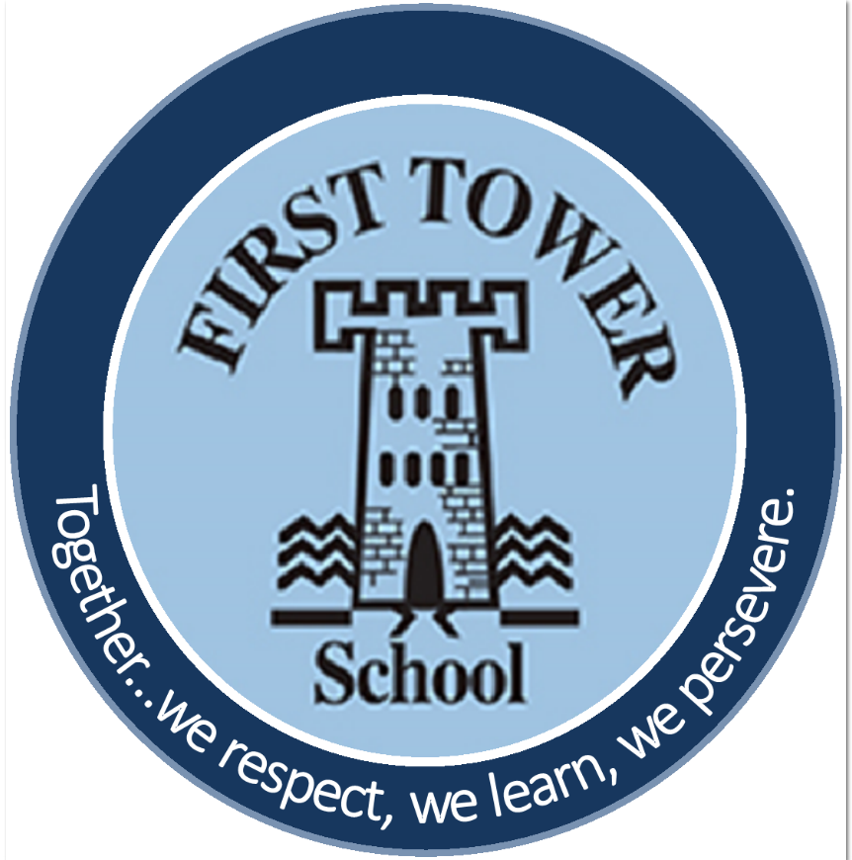

First Tower School
Art Policy
July 2023

Introduction and Vision Statement
Art is a foundation subject much valued at First Tower School. We believe that art education helps to develop and stimulate creativity, imagination and inventiveness. We believe that art develops children’s emotional well-being, resourcefulness and resilience as well as being crucial in developing an understanding of history, culture and personal identity.
At First Tower School, art is taught as a subject in its own right and also as a means to explore other areas of the curriculum. From Nursery to Year 6 we encourage children to express and represent their ideas, feelings and observations with confidence. Our aspiration is to ensure that all children at First Tower School are engaged, inspired and challenged through art.

Aims
Art should enable the children at First Tower School to communicate what they see, feel and think. Children are encouraged to experiment with their ideas, their use of colour, texture, form, pattern and different materials and processes, therefore enabling them to continue to develop and secure their skill base and become proficient in drawing, painting, sculpture and other art and design techniques.
By following the Jersey Curriculum for Art at our school, we aim to ensure that all children are provided with opportunities to equip them with the knowledge and skills to experiment, invent and create their own works of art. As pupils progress, we aim for pupils to be able to think critically and develop a more rigorous understanding of art.
Subject Content
In Key Stage 1, the children will:
- Use a range of materials creatively to design and make products.
- Use drawing, painting and sculpture to develop and share their ideas, experiences and imagination.
- Develop a wide range of art and design techniques in using colour, pattern, texture, line, shape form and space.
- Learn about the work of a range of artists, craft s and designers (including local artists), describing the differences and similarities between different
practices and disciplines and making links to their own work.
In Key Stage 2, the children will:
- Develop their techniques, including their control and their use of materials, with creativity, experimentation and an increasing awareness of different kinds of art, craft and design.
- Create sketch books to record their observations and use them to review and revisit ideas.
- Improve their mastery of art and design techniques, including drawing, painting and sculpture with a range of materials (for example, pencil, charcoal, paint, clay).
- Learn about great artists, architects and designers in history.

Planning
Planning of art sessions at First Tower School follows the Jersey Curriculum. Pupils at First Tower School also have the opportunity to take part in community art projects.
All art lessons are planned with clear learning intentions, drawn from the Jersey curriculum, which will identify the skills focus of each activity. The Long Term Plan will show progression from Year 1 to Year 6 of all art skills. Pupils at First Tower School will experience the main genres of art each year through regular and frequent practice. The six genres include; drawing, painting, printing, collage, modelling and textiles. Pupils will also study artists, architects and designers, including local artists.

How is Art taught at First Tower School?
Time allocation for art will be on average one hour per week, however many projects may be taught in blocks and through cross curricular links.

Assessment of Art
Evaluation of the programme’s effectiveness is conducted on the basis of:
• Pupil and teacher evaluation of the content and learning processes.
• Staff meetings to review and share experiences.
• Monitoring planning and lesson outcomes to ensure progression throughout the school.

Health and Safety
Risk assessments will be completed by teachers for art lessons. Children will be taught to use materials and tools with respect. Children will be taught the appropriate use of potentially dangerous tools and devices and supervised as necessary.

Role of the Subject Leader
- Support and inspire the teaching of art in the school.
- Monitor planning, teaching and learning in the subject.
- Monitor and order art and design resources as required.
- Facilitate the development of skills in art and design techniques among staff.
- Provide classroom support for staff where time can be allocated for this purpose.

Policy to be reviewed and updated by no later than _________________.

