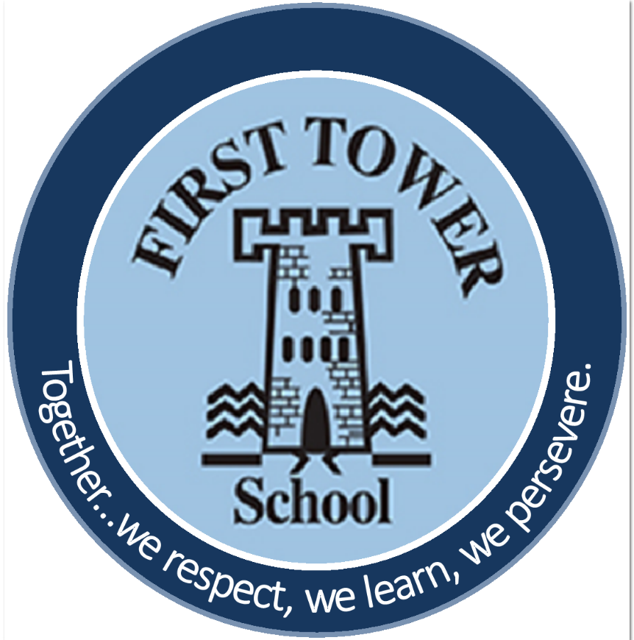
First Tower School
Early Years Policy
September 2023

Date: | September 2023
To be reviewed: | September 2024

First Tower Primary School
EARLY YEARS FOUNDATION STAGE POLICY
Our Core Purpose – To provide the children in our care with high quality environments and highly skilled staff that can support them to explore and learn about the world around them.
Our School Values – Together…we respect, we learn, we persevere
Our Aims
- To give each child a happy and positive start to their school life in which they can establish solid foundations on which to expand and foster a deep love of learning.
- To provide a happy, caring, safe and secure environment for learning, which meets the individual needs and interests of the children.
- To offer each child a wide range of new and exciting experiences and give them the opportunity to consolidate, explore and test them out along with their own, individual experiences.
- To enable each child, through encouragement and high expectations, to develop, to the full, socially, physically, intellectually and emotionally.
- To offer a structure for learning that has a range of starting points and unlimited opportunity for development.
- To encourage children to develop independence within a loving, secure and friendly atmosphere.
- To support children in building relationships through the development of social skills such as cooperation and sharing.
- To help each child to recognise their own strengths and achievements through experiencing success and developing the confidence to work towards personal goals.

The Curriculum
Both Nursery and Reception follow a curriculum based on the non-statutory documents - Development Matters and Birth to 5 Matters. These documents help practitioners to understand and support each individual child’s development pathway and helps practitioners to support children's learning and development, by closely matching what they provide to a child's current needs. The EYFS statutory framework has seven areas of learning and development, all of which are seen as important and interconnected but three areas are seen as particularly important for igniting children’s curiosity and enthusiasm for learning, for building their capacity to learn and form relationships and thrive (DfE 2014: 1.3), they support children’s learning in all other areas, they are known as the prime areas.
The prime areas are
- Communication and Language – Listening, Attention & Understanding; and Speaking
- Physical Development – Gross Motor Skills, Fine Motor Skills
- Personal, Social and Emotional Development – Self-Regulation, Managing Self, Building Relationships
The specific areas of learning develop essential skills and knowledge for children to participate successfully in society. The specific areas are
•Literacy – Comprehension, Word Reading, Writing
•Mathematics – Number, Numerical Patterns
•Understanding the World – Past and Present, People, Cultures and Communities, The Natural World
•Expressive Arts and Design – Creating with Materials, Being Imaginative and Expressive
Characteristics of Effective Learning
The EYFS also includes the characteristics of effective teaching and learning. The Nursery and Reception teachers plan activities within the Nursery and Reception classrooms with these in mind. They highlight the importance of a child’s

attitude to learning and their ability to play, explore and think critically about the world around them.
The three characteristics are
•Playing and Exploring – children investigate and experience things, and ‘have a go’
•Active Learning – children concentrate and keep on trying if they encounter difficulties, and enjoy achievements
•Creating and Thinking Critically – children have and develop their own ideas, make links between ideas, and develop strategies for doing things.
Teaching and Learning
In our Foundation Stage department, Teaching and Learning styles include whole class teaching, small group work, paired work and individual work which are all supported by on-going observations and assessment. To promote good Teaching and Learning in our school, we aim to
•Develop good relationships between home and school, so that children feel secure and develop a sense of well being
•Start from the needs of the child and plan the learning from assessments and observations
•Provide opportunities for the children to learn through first hand experiences, give clear explanations, make appropriate interventions and extend and develop play and communication skills, both inside and outside the classroom
•Plan a curriculum based on the non statutory guides ‘Development Matters’ and ‘Birth to 5 Matters’
•Provide children with the opportunity to take part in activities that build on and extend their interests and develop their intellectual, physical, social and emotional abilities.
•Enable children to develop independence and self-management
•Have clear aims and success criteria, to monitor and evaluate planning to improve what we do

Teaching and Learning within the EYFS
Nursery
We recognise that young children learn best when they are actively engaged and involved in their learning. We understand that active learning involves other people, objects, ideas, and events that engage and involve children for sustained periods. Therefore, we believe that early years’ education should be as practical as possible, and our Nursery setting has an ethos of learning through play. We recognise the importance of children’s play. It is an essential and rich part of their learning process, supporting them in all areas of development. Play is flexible and able to suit the preferred learning style of each child. It can provide multiple ways for children to learn a variety of different skills and concepts. Activities in our Nursery are designed to engage children in practical, first-hand experiences which will support children to discover, explore, investigate, develop their personal interests and areas of curiosity, and help to make sense of the world around them as they begin to understand specific concepts. Opportunities are also set up to provide children with opportunities to apply newly acquired knowledge, demonstrating their skills and level of understanding. Child-initiated learning is an integral part of the daily nursery routine and whenever possible any adult–directed activities are play based, active, and related to the children’s interests, seasonal events/celebrations, and calendar dates e.g., world porridge day, world book day, number day. We aim to support children with their learning through observing, getting involved in their play, supporting their thinking, and asking open ended questions.
Reception
We include direct, carefully planned, adult led experiences for children in the form of structured adult led teaching and adult led group activities. These are particularly important in helping children to learn specific skills and knowledge and it is often through children’s play that we see how much of this learning children have understood and taken on. Each day we follow a timetable with set routines in place. We set aside times each day when the children come together to be taught in the more traditional sense, gathered on the carpet as a class. In these slots we focus on maths, literacy, phonics, stories and ‘topic’. These sessions help to develop vital habits of learning: learning as a group, listening to the teacher, taking turns to answer etc. Reading and listening to stories play an important part of the day. We want to make sure our children have a love of

books and will leave Reception with a bank of stories they know well, both traditional and modern classics. We make sure that there are many opportunities to enjoy books throughout the day. Children have two - three guided reading sessions per week. The class teacher and the teaching assistant both lead the guided reading sessions throughout the day at any suitable given time.
Play
Learning through play is an important part of our Early Years classrooms. We believe children learn best from activities and experiences that interest and inspire them. Using children’s interests as a starting point, we provide children with stimulating, active play experiences in which they can explore and develop their learning to help them make sense of the world. They have opportunities through their play to think creatively and critically alongside other children as well as on their own. They can practise skills, build upon and revisit prior learning and experience at their own level and pace. Play gives our children the opportunity to pursue their own interests and inspire those around them. The children learn to adapt, negotiate, communicate, discuss, investigate, and ask questions. We believe it is important that adults take an active role in child-initiated play through observing, modelling, facilitating and extending their play. Getting the balance right between child-initiated play, which is controlled, and adult led activities is very important to us.
Planning
Our long-term planning identifies calendar dates as well as any whole school initiatives. It is very flexible to respond to the interests of the children during the year. Our medium-term planning provides a subject overview of each area of learning across the relevant age bands and staff ‘highlight’ what has been covered during the term. We also complete a brief overview of what we will cover in terms of display, classroom organisation, and assessment etc each term. Staff plan in more detail on a weekly basis using daily notes, observations and interactions with children to inform where the learning journey should move to. An overview of learning for the week is displayed on our parent noticeboards and shared with parents via email and/or Tapestry.

Classroom organisation
Each classroom within our EYFS department is set up in a way to provide children with experiences and activities in all seven areas of learning. Our classrooms have clearly defined areas which include a writing area, maths area, creative area, book corner, construction/small world area, outdoor area and carpeted teaching area. A variety of activities are planned for on a weekly basis. The outdoor area is an important part of all classrooms with many children choosing to learn outside for much of the day. We try to ensure that the range of activities outside reflects the different curriculum areas with these areas being clearly defined. The reception classes have a smaller outdoor area than nursery but make the most of a tricky space. To compensate for the lack of space the reception staff utilise the Key Stage 2 playground when it is empty.
Assessment, observations and Learning Journeys
Assessment is an essential part of the learning and development of children in the EYFS. It involves practitioners observing children to understand their level of achievement, interests and learning styles, and to then shape learning experiences for each child, reflecting those observations. To ensure we have evidence of a child’s progress in the EYFS we use a range of strategies all of which come together in their Learning Journeys (Tapestry). Staff have access to a school iPad which is used to capture and note observations. Parents have access to Tapestry and are encouraged to contribute to their child’s online learning journey. Each class teacher submits assessment data to CYPES via a department Tracker: children are judged as being ‘at age’ or ‘not at age.’ At the end of Reception, the class teacher assesses each child against the 17 Early Learning Goals (ELG) and comments on whether their development within each ELG is either ‘emerging’ or ‘expected. Data is submitted to the Education Department twice a year – ‘on entry’ which is submitted by October half term and ‘on exit’ which is submitted at the end of June/beginning of July.
Partnership with parents and carers
We believe that parents and carers are a child’s first educator and therefore work very closely to ensure they are involved in what we do with their child at school. We want parents to feel they can speak to us about their child at any time and feel comfortable in our setting. As well as the Nursery and Reception play and stay days prior to their child starting in our school we offer a Meet the Teacher session at the beginning of the school year. We also offer literacy

workshops for parents as well as a separate one on phonics. Parents are invited into class throughout the year to celebrate special days and events with us. On the last Wednesday of each half term we invite parents in for ‘Working Together Wednesday’ where parents can come in and work alongside their child at a specific activity e.g. a funky fingers activity, a creative activity etc. During the Autumn term parents are invited to a 1-1 parents’ meeting where we can share how their child has been settling in and share what learning has been taking place to date. Parents are invited to attend another 1-1 Parents’ Meeting in the Spring term where the focus is on celebrating their child’s achievements and progress to date and to identify any barriers to learning so that we can work together to ensure each child reaches their full potential. Class teachers are available at the start and end of the day to speak to parents about any general matters.
Transition and Induction into our EYFS classes and Year 1
Transition into Nursery
Play and Stay Sessions: One session will be offered in the summer term to all parents and children. While the children get to know each other and the nursery environment, the nursery teacher meets with each parent to gather any relevant information prior to their child starting – parents are also asked to complete an information form during these sessions. A ‘Welcome to Nursery’ pack is given out during this session. During the first week of September, we offer three play and stay sessions per child where children attend without their parents. During the second week of September, children attend nursery part time and have a staggered start. Children can take up their full 30hrs from the third week of September.
Transition into First Tower Reception Class
Play and Stay Sessions: These take place during the whole school transition days in July. Children who attend our nursery spend the morning in their new class, including having their lunch break there. Children who will start in our Reception classes in September who are not pupils in our nursery class are invited to attend the afternoon session with their parents.

Children who do not attend our nursery: During the second half of the summer term, the Early Years Coordinator together with the reception teacher/s aim to visit all children who will be joining our reception classes from a setting other than First Tower Nursery. Each visit lasts approximately 30 minutes and time will be spent interacting and getting to know the child as well as receiving any relevant information from the child’s key worker. Where a visit is not possible, we will telephone the nursery. All pre-schools have a transition form to complete and send to the receiving school in the summer term. There is also a Transition Meetings organised by CEYS in the summer term where key workers and reception teachers meet in person to receive information about children joining reception in the September.
In September, children who are ‘new starters’ to First Tower School will have two play and stay sessions which take place over the first two days of the term. Children who previously attended our nursery will start on either the third or fourth day of term. All Reception children will start school by the end of the first week of the Autumn term.
Transition into Year One
During the whole school transition days in July, our reception children will spend a day in their new classroom. They will be collected by the Year 1 teacher and will return to their reception classroom at home time. Prior to the transition days, the reception Teachers and the EYFS lead along with the SENDCo will split the reception classes ready for Year 1, ensuring the classes are as balanced as possible.
Health & Safety and Safeguarding
See School Policies and Education Department Policies for futher information
Child Protection/Safeguarding
There is a detailed Child Protection Policy operating within the school. A copy will be provided to parents on request and is available on the school website. It is the Senior Leaderships duty to ensure the policy is reviewed annually and any deficiencies within the policy addressed immediately. All Child Protection concerns will be managed in accordance with the Jersey Safeguarding Partnership Board Procedures. A copy of these procedures can be found on the Jersey Safeguarding Partnership Board website. https://safeguarding.je/

Children & Family Hub telephone number 01534 519000
Children’s Services telephone number 01534 443500
The DSL for Child Protection at First Tower School is:
Miss Shona Mulhern (Assistant Headteacher)
The Deputy DSL’s for Child Protection are:
Mrs Lyn Linton (Headteacher), Mrs Shelley du Feu (Deputy Headteacher) Mrs Kathryn Mahrer (Assistant Headteacher), Miss Lauren Colley (Lead SEN TA/pastoral lead)
First Aid
The following members of EYFS staff hold a Paediatric First Aid Qualification: Mrs Mahrer, Mrs Barlow, Mrs Jordan, Miss Truscott, Mrs Reed, Miss Bushnell, Mrs Rentsch.
Healthy Eating
At First Tower School we believe that good health in the early years helps to safeguard children’s health and well-being throughout life. We believe it is important that children develop healthy eating habits when they first learn about food and activity. We treat snack and lunchtimes as an opportunity to promote children’s social development, while enjoying food and highlighting the importance of making healthy choices.
Aims
- To make snack/lunchtimes a pleasurable and safe experience.
- To use snack time and lunchtime as an opportunity to talk to children about healthy eating, to help children to develop good eating habits and to foster social skills including speaking and listening.
- To support children and their families, creating an awareness of healthy eating and promoting as appropriate.
- Within the school setting, to provide opportunities and experiences to develop children’s knowledge and understanding of healthy eating concepts in accordance with Early Years Foundation Stage Physical Development.

Opportunities are planned throughout the year for staff to work with groups of children giving opportunities to explore flavours and textures of healthy food, through cooking activities. Children will also be able to sample foods from different cultural and ethnic backgrounds.
Water is easily accessible for all children, and they are encouraged to drink water. In nursery the snack for the week is shared on our notice board and on Tapestry to ensure parents/carers know what is provided. A range of different foods are chosen for snack and a variety of fruit is available every day. Reception parents provide their child with their own snack to have in school and we encourage parents to choose a healthy snack for this time of day. On a Friday reception hold a ‘Fruity Friday’ session where a healthy fruit or vegetable snack is provided.
Special Needs Process and Procedures
A pupil has SEN where their learning difficulty calls for special educational provision, namely provision different from or additional to that normally available to pupils of the same age.
Class and subject teachers, supported by the senior leadership team, should make regular assessments of progress for all pupils. These should seek to identify pupils making less than expected progress given their age and individual circumstances.
This can be characterised by progress which:
• is significantly slower than that of their peers starting from the same baseline
• fails to match or better the child/young person’s previous rate of progress
• fails to close the attainment gap between the child/young person and their peers
• widens the attainment gap.
It can include progress in areas other than attainment, for instance, where a pupil needs to make additional progress with wider development or social needs to make a successful transition to adult life. (Jersey Code of Practice 2017)

The special needs co-ordinator Miss Shona Mulhern must be consulted about all special needs issues and at no time should any outside agencies be consulted or contacted without her prior knowledge.
It is the responsibility of the special needs co-ordinator to contact all personnel from other agencies.
Equal Opportunities
Our aim at First Tower is to create a positive, stimulating and happy learning environment through which all children will achieve success and develop their potential to the full. We look to promote their spiritual, moral, cultural and physical development so that in time they will be ready for the opportunities, responsibilities and experiences of adult life. All children, regardless of race, creed, culture or sex will be treated equally in every aspect of school life

