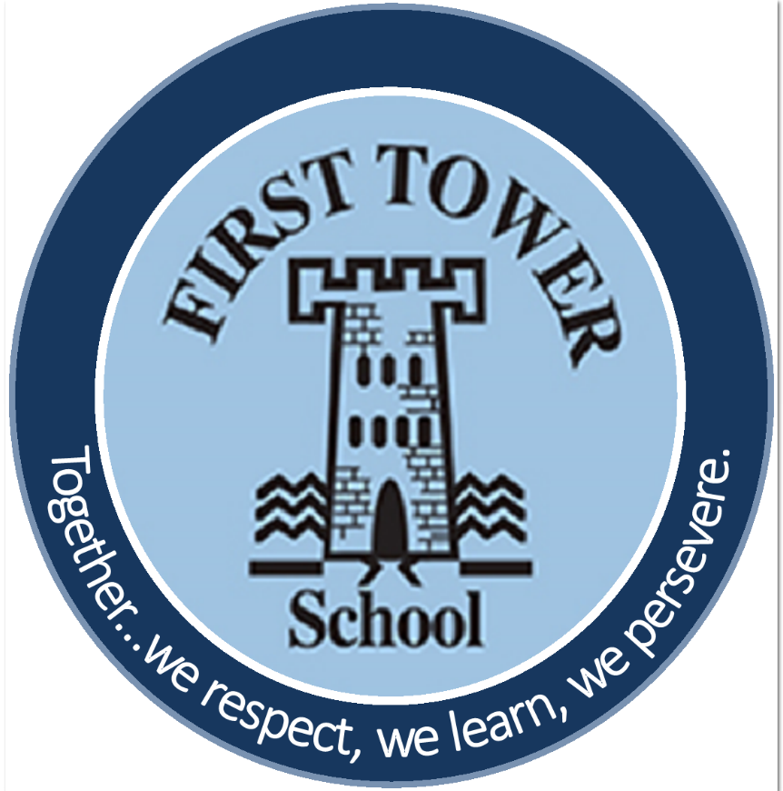

First Tower School
MLL - Multilingual Learner Policy
February 2023

Mission Statement from the ‘Language Policy for Jersey Education’ (2022)
Jersey schools encourage, welcome, and respond to a diverse range of language strengths, needs and identities, with the task of preparing pupils to leave school/college with the linguistic, academic, and social skills and competencies they require to become successful members of the community. A key element for success is empowering children to value their own language and cultures, and those of their peers. Raising the profile of all languages has a positive impact on inclusion and well-being for pupils.

- Introduction
At First Tower School, we are committed to providing the best possible education for all our pupils, including those whose home language is other than English. All pupils are entitled to the highest standard of education to ensure they are suitably prepared for an increasingly competitive world of work.
Over 40.6% of our pupils are identified as ‘multilingual’, or ‘MLL’. MLL is defined in the new ‘Language Policy for Jersey Education’ (2022) as ‘any child who has a language or languages beyond English in their linguistic repertoire’. They bring with them a rich diversity of cultural and linguistic backgrounds that serve to make First Tower School so unique.
Through our Teaching and Learning Policy, we aim to respond to the diverse learning needs of all pupils to overcome potential barriers to learning and assessment, ensuring there is equality of access to the curriculum.

- Aims and Objectives
We aim to ensure that all MLL pupils:
- feel welcomed and participate fully within our school community.
- value their home language and culture, using them as the foundation in their acquisition of English.
- are encouraged to continue developing proficiency in the home language, both inside and outside the classroom.
- are provided with the support, knowledge, and confidence to develop fluency and accuracy in English.
- can access learning across the curriculum through their developing use of language.

3. Key Principles
We believe:
- language develops best when used in purposeful contexts across the curriculum and in social settings.
- effective use of language is crucial to the teaching and learning of all subjects.
- the language demands of learning tasks need to be identified and planned for, with attention both to initial access and extension activities.
- access to learning requires attention to words and meanings embodied in each curriculum area. Meanings and understandings cannot always be assumed but need to be explored.
- staff have a crucial role in modelling the correct use of language.
- the focus and use of additional support is clearly identified through the planning process and provision grids.
- all pupils have an entitlement to the Jersey Curriculum.
- a distinction is made between ‘MLL’ and ‘SEN’.
- teachers are aware of the importance of pupils’ home languages and understand that the acquisition of concepts and skills benefits from well-developed home language, especially in the early years. Literacy in the home language enhances the acquisition of English.
- all languages, dialects, accents, and cultures have equal value and status.

4. How our Aims, Objectives, and Key Principles will be met.
Admissions, induction, and initial assessment of International New Arrivals (INAs)
International New Arrivals can arrive at any time of the year, within any year group and with differing levels of Proficiency in English (PIE). They may have had different educational experiences prior to arriving in Jersey. These pupils have the dual challenge of learning English while learning through English.
To ensure a smooth induction process takes place, a member of the SLT and / or the ‘MLL Lead’ will arrange a meeting to welcome new parents and pupils to the school. At this meeting, information about the child and family will be obtained to form a profile of languages spoken at home along with the pupil’s strengths and needs. Whenever possible bilingual support will be arranged to help facilitate this meeting.
Class teachers will be provided with as much information regarding the child prior to the first day of arrival at school. Accordingly, they will arrange for another pupil in the class to ‘buddy’ her/him. Ideally this will be a child who also speaks the INA’s home language.
Within the first few weeks of arrival, the EAL Lead Key Worker will complete an initial assessment of the child using the Bell Foundation Initial EAL Assessment. Whenever possible, this will be administered in the child’s home language and information will be passed on to the relevant parties, e.g., ‘MLL Lead’, class teacher, SENCo, etc.
Classroom practices
All pupils have an entitlement to the 2014 Jersey Curriculum, ensuring it is broad and balanced, and linked to the linguistic and cultural heritage of the pupils in the school.
Teachers are cognisant of the different learning styles of their pupils and adapt their teaching strategies accordingly. This is particularly relevant for our MLL pupils who have the dual task of learning English alongside the content of the curricular areas. They should identify key features of language which are necessary for effective participation, for example key words, certain patterns of grammar, uses of language, and forms of text.
Regular reference to the Bell Foundation EAL Assessment Framework will track the progress of the school’s MLL pupils. As a consequence, appropriate interventions or strategies will be considered to create optimal conditions for pupils to achieve and reach their full potential, ensuring that their educational needs are being met in terms of learning, progress, and well-being. Closing existing achievement gaps between MLL students who are learning English and their native English-speaking peers is one of the aims of the new ‘Language Policy for Jersey Education’ (2022).

Celebration of languages
Languages form an integral part of life. For people living in Jersey languages contribute to our diverse and vibrant society, and so should be acknowledged and celebrated. The promotion and development of languages is essential to identity and inclusion.
The home language that each child brings to school with them is a critical element of their cognitive, emotional, social, and identity development. MLL pupils benefit from having their home language included and leveraged in their education.
Research focused on educating language learner students points to a strong correlation between maintenance and development in home languages and mastery of the school language in their new environment. Staff at First Tower School encourage the parents of our MLL pupils to maintain and develop their home language with their children so that they develop the skills of verbal communication.
The use of languages other than English, e.g., home languages, Jèrriais, French, will be encouraged through the school’s physical and digital environments, e.g., signage in multiple languages, quality dual language texts, as well as visiting speakers.
5. Foundation Stage
The Early Years Team at First Tower School appreciates the importance of understanding the linguistic repertoire of their pupils. This is usually facilitated through home visits, induction sessions, transition, etc. Whenever possible, bilingual support is arranged for home visits prior to children starting in the Nursery.

A child’s home language provides the roots to learning additional languages, and parents should be encouraged to continue to use their home languages to strengthen and support their children’s language proficiency as they join new environments. Upon arrival at their new setting, parents can accompany their child whilst they settle in and are free to use either the home language, or English, depending on what they feel most comfortable with.

A robust literacy scheme of work is in place based on the ‘Letters and Sounds’ scheme, which gives all pupils access to daily practice in phonics, letter sounds, blends, and vocabulary, using visual and oral teaching and learning techniques.

6. Key Stage One and Two

Along with all other pupils in the class, MLL pupils are supported by the class teacher and, when available, a teaching assistant. Whenever possible, any MLL pupils identified as needing additional support will receive time-bonded targeted support from a Teaching Assistant. Presently, this support must come from allocated SEN time.

The EAL Lead Key Worker allocated to First Tower by the Multilingual Advisory Service will support those pupils at Proficiency in English (PIE) Bands A and B, using a bespoke scheme of work to develop their English. These pupils will receive targeted English as an Additional Language (EAL) Support which is now defined as ‘a supportive provision (stand-alone and/or integrated) designed to help pupils who are learners of English develop full academic proficiency’.

7. Assessment and Recording

All International Arrivals (INAs) are assessed by the EAL Lead Key Worker within the first few weeks of admission using the Bell Foundation’s Initial Assessment. From this assessment a pupil’s level of English is identified using the five proficiency bands: A (New to English), B (Early Acquisition), C (Developing Competence), D (Competent), E (Fluent), and this will inform the type of targeted support, if any, that the MLL pupil would receive.

Any school assessment, e.g., PIRA, PUMA, SATs, GL etc. must take into account the needs of their MLL pupils to ensure equitable access to assessment of all types.

8. Special Educational Needs and Gifted and Talented Pupils

As with any other pupil, all MLL pupils are given equal access to SEN or G&T provision.

9. Links with parents and the community

First Tower School endeavours to build robust community links so that all parents and caregivers feel welcome and involved in the life and fabric of the school. The development of a strong school-home-community network positively impacts on pupils’ learning and self-esteem. Schools reaching out to the wider community through events such as performances and charity events will reflect the identities and cultures of the school community.

We value parental involvement and appreciate the help and support they provide to enhance their children’s learning. Parents are always encouraged to meet with class teachers, the SENCO, or a member of the SLT, to discuss the needs of their child/ren

Policy to be reviewed and updated by no later than September 2023

