First Tower School
Foundation Stage Department

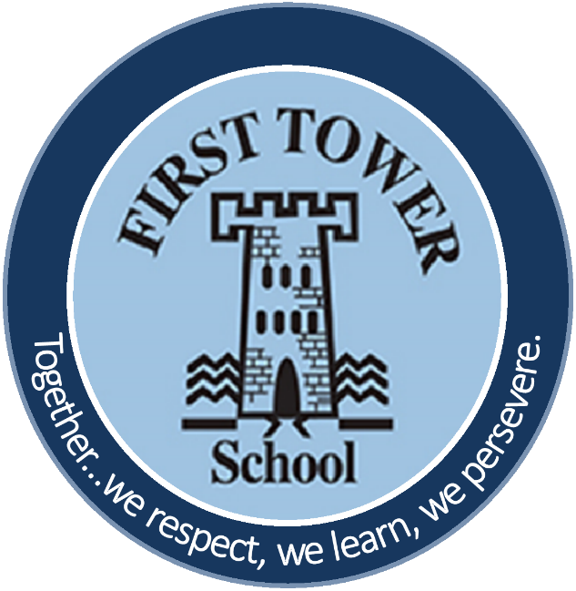

Parent Handbook
Reception

Starting School is an exciting and sometimes challenging time for children and parents. The aim of this booklet is to provide a useful guide towards making this an enjoyable and positive experience for everyone.

First Tower School Foundation Stage Department recognises that all children are special. We will cherish them, work with them and create opportunities for them to grow in every way. We therefore aim to:

- Develop a partnership with parents/carers, enabling children to learn at home and at school.

- Provide an environment which encourages children to talk, to listen and to share with adults and children.

- Provide a range of activities, which enables children to discuss, think, question and learn.

- Provide opportunities for parents/carers to share the progress and achievements of their child, to contribute to our observations and assessments of their child and therefore support our planning.

- Work with other schools and settings, in order to provide a continuity of experience and enjoy a positive transition for all.

- Interact with children so they gain knowledge and understanding of the world, of themselves and of others, whilst building a foundation for lifelong learning.

- Provide an environment, which is welcoming, safe and stimulating, where children enjoy themselves, grow in confidence and fulfil their potential.

Reception Staff

There are four permanent staff in the Reception department:

Two qualified teachers and two teaching assistants.

The staff are highly trained and experienced in working with young children. We know that children are very special and will encourage them, cherish them and work with them to help them grow and develop all areas of learning.

Lunchtime Staff

There are two lunchtime supervisors responsible for the children’s care during lunchtime, one for each class. Their roles involve helping the children when eating and during outside play. The lunch staff liaise with the reception staff on a day to day basis.

Other Staff

Occasionally we have students training in our school and sometimes we have adults covering for staff during training or absence. We also host Project Trident students during the course of the year.

************************************************

The Foundation Stage Curriculum

Play underpins all development and learning for young children. It is through play that children develop intellectually, creatively, physically, socially and emotionally. Within the reception classes we provide a wide range of learning opportunities to enable the children to access a variety of experiences. Every child starts reception at a different stage of development. Their individual needs are assessed and staff plan appropriately to meet those needs, providing suitable resources and activities which allow for progression.

Our reception provision is based on ‘Development Matters in the Early Years Foundation Stage (EYFS), which sets the standards for learning, development and care for children from birth to five. It stresses the importance of providing well-planned experiences based on children’s spontaneous play, both indoors and outdoors.

The EYFS curriculum states that the ways in which children engage with other people and their environment – playing and exploring, active learning, and creating and thinking critically all underpin learning and support the child to remain an effective and motivated learner.

The ‘Development Matters’ document describes Prime Areas of learning, which are fundamental and develop quickly in response to relationships and experiences and therefore support all other areas.
These areas are:

• Communication and language development involves giving children opportunities to experience a rich language environment; to develop their confidence and skills in expressing themselves; and to speak and listen in a range of situations.

• Physical development involves providing opportunities for young children to be active and interactive; and to develop their co-ordination, control, and movement. Children must also be helped to understand the importance of physical activity, and to make healthy choices in relation to food.

• Personal, social and emotional development involves helping children to develop a positive sense of themselves, and others; to form positive relationships and develop respect for others; to develop social skills and learn how to manage their feelings; to understand appropriate behaviour in groups; and to have confidence in their own abilities.

‘Development Matters’ also talks about Specific Areas of learning which include essential skills and knowledge. They develop from the prime areas and provide important context for learning.

These areas are:

• Literacy development involves encouraging children to link sounds and letters and to begin to read and write. Children must be given access to a wide range of reading materials (books, poems, and other written materials) to ignite their interest.

• Mathematics involves providing children with opportunities to develop and improve their skills in counting, understanding and using numbers, calculating simple addition and subtraction problems; and to describe shapes, spaces, and measures.

• Understanding the world involves guiding children to make sense of their physical world and their community through opportunities to explore, observe and find out about people, places, technology and the environment.

• Expressive arts and design involves enabling children to explore and play with a wide range of media and materials, as well as providing opportunities and encouragement for sharing their thoughts, ideas and feelings through a variety of activities in art, music, movement, dance, role-play, and design and technology.

In reception we plan educational programmes and experiences that build on children’s interests and their spontaneous play as much as possible. We use our observations of the children to help us understand the child’s current stage of development and ensure that the activities are well matched to the children’s needs and address the next steps in their learning.

Partnership with Parents

'Parents are children's first and most enduring educators.'
(Department of Education - Early learning goals, 1999)

Parents are the first teachers of their children; therefore it is essential that we work with you to help your child feel comfortable and progress. When parents and staff work together, the results have a very positive impact on a child’s development and learning. Please do not hesitate to share any triumphs or tribulations you may have and in return we will keep informed of your child’s experiences and developments. We have the opportunity to speak to you each day, however if you need to speak to a member of staff in any depth, please make an appointment and we will be pleased to meet with you.

As a staff team we believe we can more effectively meet your child’s needs if we work together. We value your input as your child’s primary carer and as an expert on your child. We rely on your partnership, so together we can provide your child with the highest quality education and care. This will make their time at school happy and enjoyable.

Communication with Parents

Each term we will send home a work profile letter, which outlines our activities for the term ahead.
Both classes have a parent’s noticeboard - please check these boards regularly and look out for any other notices on the parents’ board for things we may need brought in and events going on. (Covid 19 dependent)
We will also share our ‘Learning for the Week’ which will provide the specific learning focuses for the week.
You will receive regular newsletters from the main school and from us in order to keep you up to date with events and activities.
In the autumn and spring terms, all parents are invited to attend parent consultations where your child's progress to date will be shared with you and we can address any questions you may have. At the end of the summer term parents will receive a written report, summarizing their child’s achievements during the year.

‘Tapestry Online Learning Journey’

We use Tapestry (an ‘Online’ Learning Journey) as a means of collecting evidence of children’s learning/development across the Development Matters Framework.

Tapestry is an incredibly safe site and it fulfills all of the criteria that we put in place to ensure our school data is kept safe, private and secure. A risk assessment for using this site has been completed and the most recent terms and conditions of the company have been obtained and checked thoroughly. In order for us to proceed and to set up an online learning journey for each child we need to ask for your permission in writing before we can set up an account for your child.

Once the online Learning Journeys have been set up and the staff have begun adding observations and assessments to each child’s Learning Journey (around the end of September) all parents will be given secure access via an email address and password.

This online Learning Journey will consist of photos, videos, learning statements and, in addition to being able to view our contributions parents are able to add to it by uploading your own photos and comments, or commenting on observations made by us.

EExAT

At First Tower School we use an online assessment system developed by Early Excellence. It is designed to capture key moments of your child’s learning and development, which then helps us plan new experiences and activities for your child. We will seek your permission for this when your child starts school.

School closures

You will be asked to fill out a form giving us detailed instructions about the care of your child should the school be forced to close during the school day due to severe weather/extenuating circumstances etc. This will include contact telephone numbers and your instructions for the collection of your child. No child will be allowed to leave with any adult other than those specified by the parents.

Uniform

All Reception children are required to wear school uniform.
For details of the type of uniform required for this age, please see our accompanying School Uniform brochure.

All items of uniform must be clearly marked with your child's name and which class they are in.

For safety reasons jewellery is not allowed to be worn in school by Reception pupils. If parents have special requests, they need to address these to the Headteacher.

Health

Please make sure that we are informed of any medical needs or allergies.
If your child is unwell please keep him/her at home and inform the school as soon as possible.
Please note: children should not return to school until 48 hours after diarrhea/vomiting has finished.

Please ask for the school’s policy on ‘Administration of Medicines’ if you need advice on what we can and cannot administer. There is no obligation on the school to administer medicine.
Accidents

We will endeavour to report any accidents to you, however minor, and as such it is important, we have an up-to-date telephone number in case we have to contact you urgently. If your child bumps their head during the day a Head Bump Form will be sent home with your child telling you what part of the head was injured. This will describe any symptoms your child may display that require attention.

School Times

- School starts for all children at 8-45am although parents are welcome to bring their child into class from 8-30am.
- The school day ends at 2-55pm. (Covid-19 dependent)

Please help us by collecting your child promptly.

Term Dates

The Yearly Term Dates can be found both on the school website www.firsttower.sch.je and on the Government of Jersey website www.gov.je – Education/Term Dates.

Lunchtime

Please provide food that you know your child will eat and small portions are best. Please peel and cut any fruit you provide. School policy does not allow fizzy drinks, glass bottles, sweets or chocolate. Please also note that we are a nut free school.

Snack Time

Parents need to provide a healthy snack for their child to eat during the morning break. This needs to be put into their book bag and kept separate from lunch. You will also need to provide a drink. In line with school policy, we kindly request that only water is provided for snack time and that it is sent to school in a clearly labelled bottle so that your child can find their bottle on the water table. If you would like a school water bottle these are on sale at the school office. Another drink needs to be provided for lunchtime and placed in the lunchbox.

Toys

We request that no toys from home are brought to school. Ownership is a difficult concept for young children and a precious possession 'borrowed' or damaged is bound to lead to distress.
A final note

We are sure your child will enjoy his/her time in Reception and we look forward to meeting you. If you have concerns or worries during your child's time with us, please do not hesitate to contact the teacher concerned who will assist you in every way possible.

First Tower School, La Route de St Aubin, St. Helier, Jersey, JE2 3SD
Email: admin@firsttower.sch.je
Tel: 01534 721066 Fax: 01534 285840



